**User Details**

**Serial Checker (SC0001)**

*“Captures the user oriented details of the project”*

**Rev A**

**05-JUL-2024**

**Purpose 1**

**Abbreviations 1**

**References 2**

**User Story 2**

Context 2

Basic Wish 2

Concept Sketches 3

- Image 1: Hardware peripherals of the device 3

- Image 2: Examples of screens on device’s LCD 3

- Image 3: General flow of “windows” on screen 4

**Revision History 4**

# Purpose

The purpose of this document is to capture the user oriented details of the project (namely the user story and use cases). This document reflects the original (and developing) ideas on what the final product should be and do.

# Abbreviations

| **Abbreviation** | **Description** |
| --- | --- |
| GPIO | General Purpose Input Output- typically in reference to digital, bidirectional pins |
| UART | Universal Asynchronous Receiver Transmitter |
| I2C | Inter-Integrated Circuit |
| SPI | Serial Peripheral Interface |

# References

| **Name** | **Document Number** |
| --- | --- |
| - | - |

# User Story

This section captures the raw “story” behind why the project exists to begin with (besides being a means to practice embedded firmware/product development skills).

## Context

I have a personal project (Project RISCII) that involves designing a softcore microprocessor from scratch (core processing, peripherals, etc). This design includes various external peripherals connected to via GPIO pins. In detail, the microprocessor includes external ports to GPIO pins, UART pins, I2C master pins, and SPI master pins (i.e. microprocessor implements the master side of I2C and SPI networks).

It is important to ensure these pins are driven with the expected waveforms. This is most easily done with a logic analyzer, which I unfortunately do not have (and am not in a position to buy one at the moment). This in mind, it would be convenient to have a device that can let me test each of these circuits in a convenient manner (or at least more convenient than slowing the microprocessor down and filming LEDs update).

## Basic Wish

The basic device would physically support up to 4 “sampling” lines, some human input devices (e.g. buttons), and a screen to display data. Using the input devices and screen, the user can set up the device to sample one of the four peripherals:

* GPIO pins (2 inputs, 2 outputs)
* UART (2 pins, full duplex)
* I2C (2 pins)
* SPI (4 pins including chip select)

The user can select a sample rate and size, as well as choose between preset options about when to trigger the sampling. Furthermore, the user can select “response” data and choose between preset options on when to send it (these options likely vary between peripheral).

The device should be able to show the sampled data in live time (to a reasonable extent). For more in-depth analysis, the user can have the sampled data exported over the device’s UART/USB.

For the sake of project brevity (and being realistic with the available hardware), many of the details regarding “options” (e.g. trigger types, sample rate minimums, etc) can be either predetermined/hard-coded or based on what the hardware is capable of. The larger concern is making sure there is a decent amount of configurability for the sake of verifying the hardware peripherals work.

## Concept Sketches

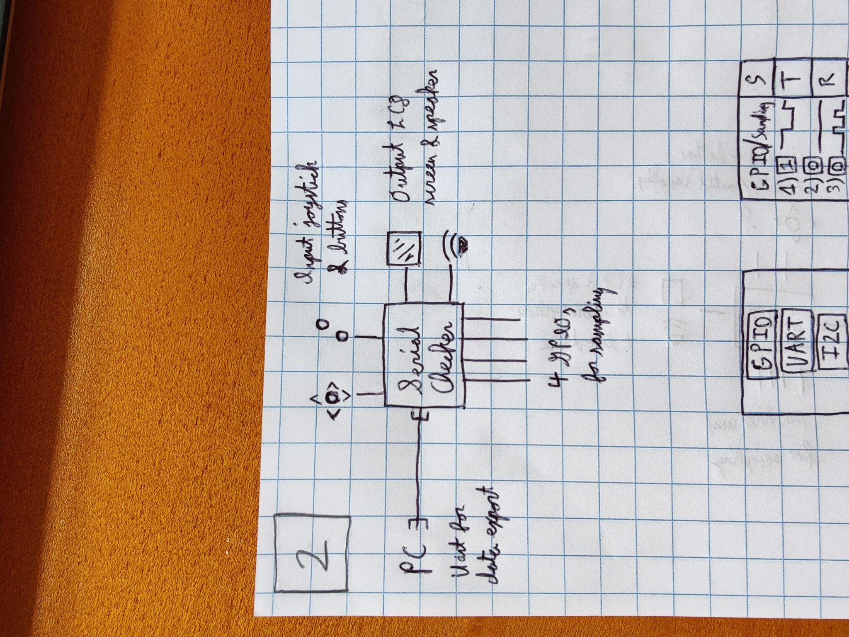

#### Image 1: Hardware peripherals of the device

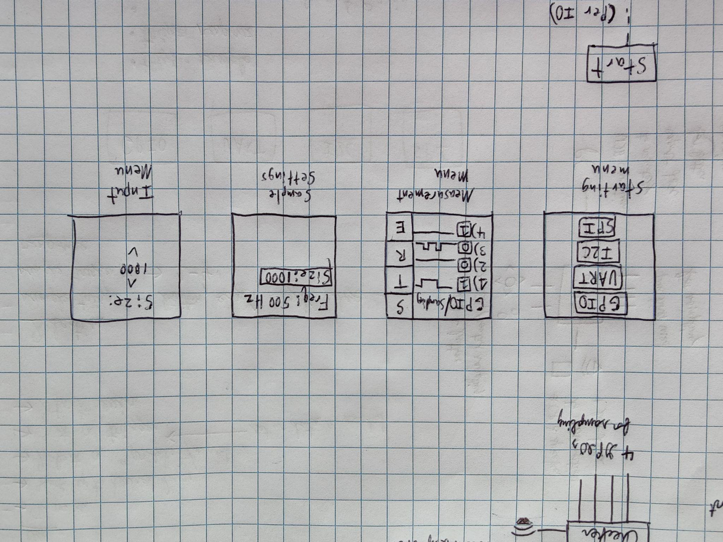

#### Image 2: Examples of screens on device’s LCD

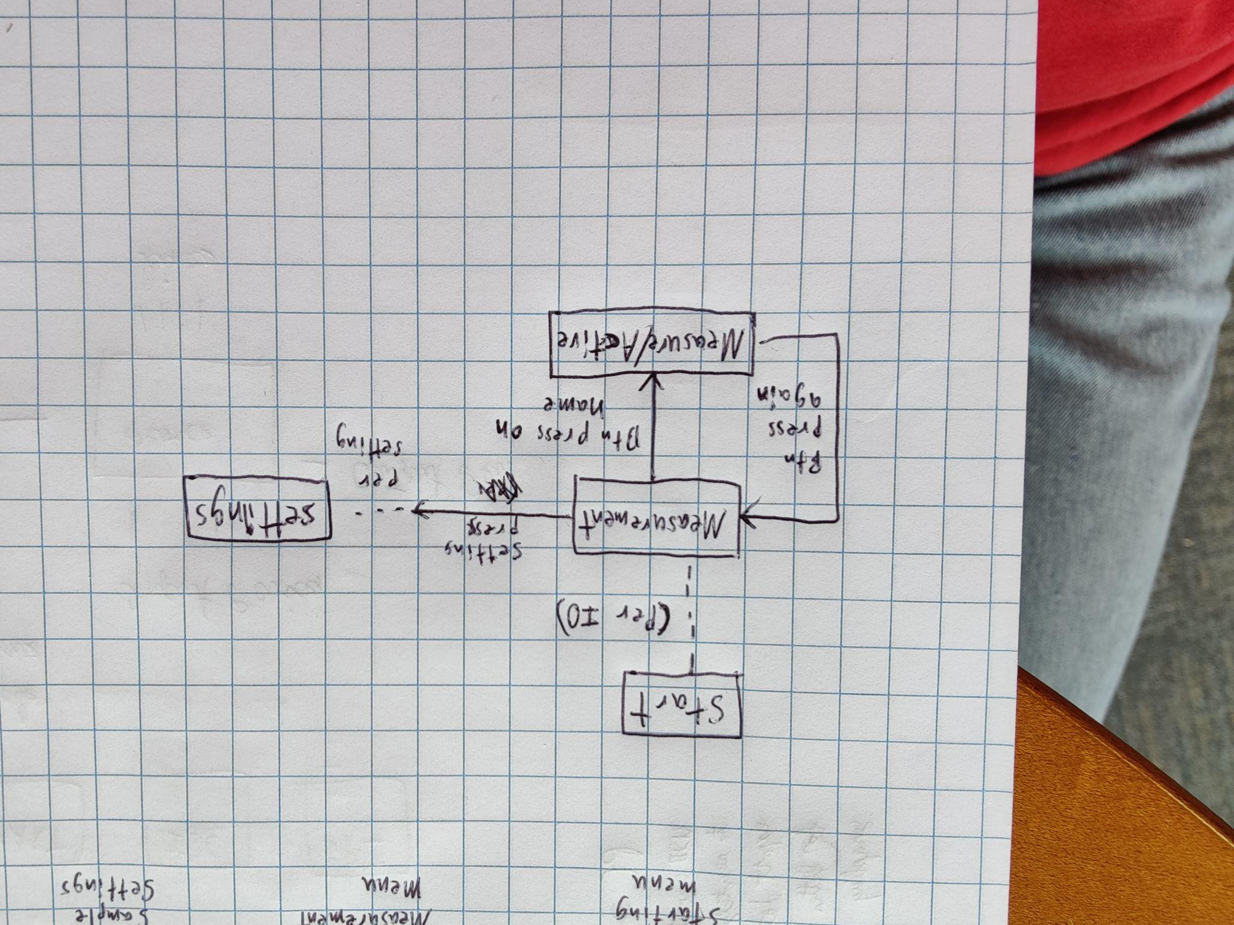

#### Image 3: General flow of “windows” on screen

# Revision History

| **Rev** | **Date** | **Description of Changes** | **Initials** |
| --- | --- | --- | --- |
| A | 05-JUL-2024 | Initial draft of user story | J.E. |
|  |  |  |  |
|  |  |  |  |